**Summer Internship Project Report**



On

**Equity Research and Valuation**

**At CRISIL Ltd**

By

**Utkarsh Chaudhary**

**BMS (Finance) Class of 2019**

**(17073)**

In Partial Fulfilment of the Requirements for the Award of the Degree in

Bachelor of Management Studies

(2018)

**SHAHEED SUKHDEV COLLEGE OF BUSINESS STUDIES**

**(University of Delhi)**

**Declaration Page**

I hereby declare that this internship report, submitted to Shaheed Sukhdev College of Business Studies, University of Delhi is a record of an official work done by me under the guidance of Ms. Pooja Jha, Senior Research Analyst The project is submitted in the partial fulfilment of the requirement for the award of the degree of Bachelor of management studies. The results embodied have not been submitted to any other university or institute for the award of any degree or diploma.

**______________ _________________**

**(Student Signature) (Supervisor Signature)**

**Acknowledgement**

The internship opportunity I had with CRISIL Ltd. was a great chance for learning and professional development. Therefore, I consider myself as a very lucky individual as I was provided with an opportunity to be a part of it.

I am also grateful for having a chance to meet so many wonderful people and professionals who led me though this internship period.

Bearing in mind previous I am using this opportunity to express my deepest gratitude and special thanks to Ms. Pooja Jha, Senior Research Analyst who in spite of being extraordinarily busy with her/his duties, took time out to hear, guide and keep me on the correct path and allowing me to carry out my project at their esteemed organization and extending during the training.

I express my deepest thanks to Mr. Anirudh Natarajan, Research Analyst for taking part in useful decision & giving necessary advices and guidance and arranged all facilities to make life easier. I choose this moment to acknowledge his contribution gratefully.

It is my radiant sentiment to place on record my best regards, deepest sense of gratitude to Mr. Amol Shembekar, Associate Director for their careful and precious guidance which were extremely valuable for my study both theoretically and practically.

I perceive as this opportunity as a big milestone in my career development. I will strive to use gained skills and knowledge in the best possible way, and I will continue to work on their improvement, in order to attain desired career objectives. Hope to continue cooperation with all of you in the future,

**Letter from the Company for Completion**

**Table of Content**

|  |  |
| --- | --- |
| Topic |  |
| **1.Introduction** |  |
| 1.1 About CRISIL |  |
| 1.2 GR&A |  |
| 1.3 FR Department |  |
| **2.Equity Research and Valuation** |  |
| 2.1 About the Project |  |
| 2.2 European Retail Industry |  |
| 2.3 Groupe Casino Background |  |
| **3.Financial Modelling Project** |  |
| 3.1 Forecasted Financial Statements and   Other Schedules |  |
| 3.2 Key Assumptions for Forecasting |  |
| 3.3 DCF Valuation |  |
| **4.IFRS 16** |  |
| 4.1 Background |  |
| 4.2 Objective |  |
| 4.3 Scope |  |
| 4.4 Key Changes |  |
| 4.5 Effects On Financial Statements |  |
| 4.6 Impact on Overall Retail Industry |  |
| 4.7 Impact on European Retail Companies |  |
| **5.References** |  |

**Chapter 1: Introduction**

**1.1 About CRISIL Ltd**

CRISIL is a leading, agile and innovative global analytics company driven by its mission of making markets function better.

It is India’s foremost provider of ratings, data, research, analytics, and solutions. A strong track record of growth, culture of innovation and global footprint sets us apart. It has delivered independent opinions, actionable insights, and efficient solutions to over 100,000 customers.The businesses operates in India, the United States (US), the United Kingdom (UK), Argentina, Poland, China, Hong Kong, Singapore, and the United Arab Emirates (UAE).

It is in majority owned by S&P Global Inc., a leading provider of transparent and independent ratings, benchmarks, analytics, and data to the capital and commodity markets worldwide.

The clients range from micro, small and medium companies to large corporates, investors, and top global financial institutions.

We work with commercial and investment banks, insurance companies, private equity players and assetmanagement companies globally.

They also work with governments and policy makers in the infrastructure space in India and in other emerging markets.

**Sectors Covered -**

* Automobile
* Industrial
* Consumption Products
* Energy
* Financial
* Infrastructure
* IT, Media & Telecom
* Travel, Health, Retail and Others

**1.2 About Global Research and Analytics**

As world's largest and top-ranked provider of high quality research and cutting edge analytics services, we have been helping buy side and sell side clients grow their revenue and strengthen their market position.   
The research support has enabled clients to improve their institutional ranking, increase coverage, enter new markets, deliver path breaking strategies, among others.  
The strong derivatives, quantitative, risk and actuarial specialists have been helping clients apply incisive analytics to internal models, transition to more robust risk and trading platforms, measure risk in a more real-time manner, and comply with regulatory requirements including model validation, stress testing and others across geographies.

**1.3 About Financial Research Department**

CRISIL Global Research & Analytics has proven experience in producing high quality research and data analytics for sell-side and buy-side firms including world's leading investment banks, asset and wealth management firms, private equity firms, commercial banks, corporations, consulting firms and insurance companies.  
  
CRISIL’s strong data analytics capabilities, coupled with the firm’s deep industry knowledge, help clients gain differentiated insights across domains such as investment research, digital marketing, sales and marketing, client analytics, and portfolio analytics to support outcomes such as alpha generation, increase in revenues, and higher return on investments.

**2. Equity Research and Valuation**

**2.1 About the Project**

Equity research refers to the analysis of a company’s fundamentals, financial statement analysis, financial modelling and scenario building for equity recommendations

The main purpose of equity research is to provide investors with detailed financial analysis and recommendations on whether to buy, hold, or sell a particular investment

This Project had a aim to analyze the company **Casino Groupe** by understanding the economy, sector, markets in which it operates, business model, accounting principles ,and deep understanding of financial statements to forecast the financial statement for next 5 years to find out the the present value of all expected future [cash flows](https://corporatefinanceinstitute.com/resources/knowledge/accounting/statement-of-cash-flows/), discounted at the appropriate discount rate

by using a DCF Method of Valuation.

**Framework Followed**

The framework behind creating a DCF model is as follows:

* **Project Future Cash Flows** - this is usually done from a 3-statement projection model or by using simple assumptions about Revenue, Tax, Depreciation, Amortization etc and calculating free cash flow from there
* **Calculate the Discount Rate** - this is either taken to be a simple percentage or is calculated using WACC
* **Discount Future Cash Flows** - either by using the Mid-Year discount or a simple discount period, it is fairly simple to calculate the present value of future cash flows
* **Estimate Terminal Value** - Terminal Value is then estimated either by using a terminal exit multiple (usually an EBITDA multiple) or with a Terminal Growth Rate (Gordon Growth Method)
* **Find the Net Present Value** - to find the net present value simply discount the terminal value (again using WACC or a simple %) and then add that to the sum of the discounted cash flow values

**2.2 European Retail Industry**

* Europe has highest number of companies Europe has the highest number of Top 250 retailers, with 87 companies based in the region (34.8 percent), up from 82 in FY2016. Its share of Top 250 revenue was 33.8%.
* Its share of Top 250 revenue was 35.1%. Retailers from Europe’s largest markets namely Germany, UK and France, contributed twothirds of the total regional revenue in FY2017.
* Germany has the largest companies with an average size of US$24.7 billion, closely followed by France with an average size of $24.2 billion, which are much higher than the average Top 250 size of US$18.1 billion.
* European retailers remain the most globally active as they search for growth outside their mature home markets
* Nearly 42.3 percent of their combined revenue was generated from foreign operations in FY2017, which is almost double the 23.6 percent for the Top 250 group as a whole.
* Eighty-three percent of the region’s companies operated internationally, expanding well beyond their home country borders with a presence in 16 countries on average.
* French retailers have by far the most global retail networks, with operations on average in 29 countries.
* European retailers were the most globally active among the top 250.
* Almost 42.3 percent of European companies' combined revenues was generated from foreign operations in FY2017, compared with 23.6 percent for the top 250 as a whole.
* Eighty-three percent of the European companies in the list operated internationally; the average number of countries in which they had a presence was 16 countries.
* French retailers were the most global, with a presence in 29 countries on average.

**List of Some of Biggest European Retail Companies**

|  |  |  |  |
| --- | --- | --- | --- |
| Name | Format | Country | FY 2017 Revenue, (in billions) |
| Schwarz Group | discount store | Germany | $111.8 |
| Tesco PLC | hypermarket/supercenter/superstore | U.K. | $74.0 |
| Ahold Delhaize | supermarket | Netherlands | $72.3 |
| Auchan Holding SA | hypermarket/supercenter/superstore | France | $58.6 |
| Casino Guichard-Perrachon S.A | hypermarket/supercenter/superstore | France | $42.6 |
| E. Leclerc | hypermarket/supercenter/superstore | France | $41.5 |
| Metro AG | cash & carry/warehouse club | Germany | $41.0 |
| J Sainsbury PLC | hypermarket/supercenter/superstore | U.K. | $36.6 |

**2.3 Company Background**

**Groupe Casino**

* Casino Group or Casino Guichard-Perrachon is a French mass-retail Group.
* It was founded on 2 August 1898 by Geoffroy Guichard under the corporate name Guichard-Perrachon & Co.
* Casino Group, currently managed by [Jean-Charles Naouri](https://en.wikipedia.org/wiki/Jean-Charles_Naouri), is quoted on the Paris Stock Exchange, with the Rallye company as a majority shareholder
* As an historical player in mass retail in France, the Group also started to grow internationally at the end of the 90s

**Key Innovations**

* the first distributor's brand in 1901,
* the first self-service store in 1948
* the display of a sell-before-date on consumer products in 1959

**Types of Formats**

* Hypermarkets-Geant Casino
* Supermarkets –Casino Supermarkets
* Convenience stores –Monoprix, Franprix, Spar,Sherpa and Le Petit Casino
* Discount Stores – Leader Price and Cdiscount
* E-Commerce – Cdiscount

Group also started to grow internationally at the end of the 90s. It acquired GPA and Grupo Éxito in 1999, major companies in mass distribution in Brazil and in Colombia.

## **Activities of the Group**

### **Internationally**

* The Group directs its development towards countries with a strong growth and profitability potential, where its branches have strong local roots.
* South America has therefore become its priority area for development.
* The Group is leader on the market in Latin America and more particularly in Braziland in Colombia.

**World Wide Presence**

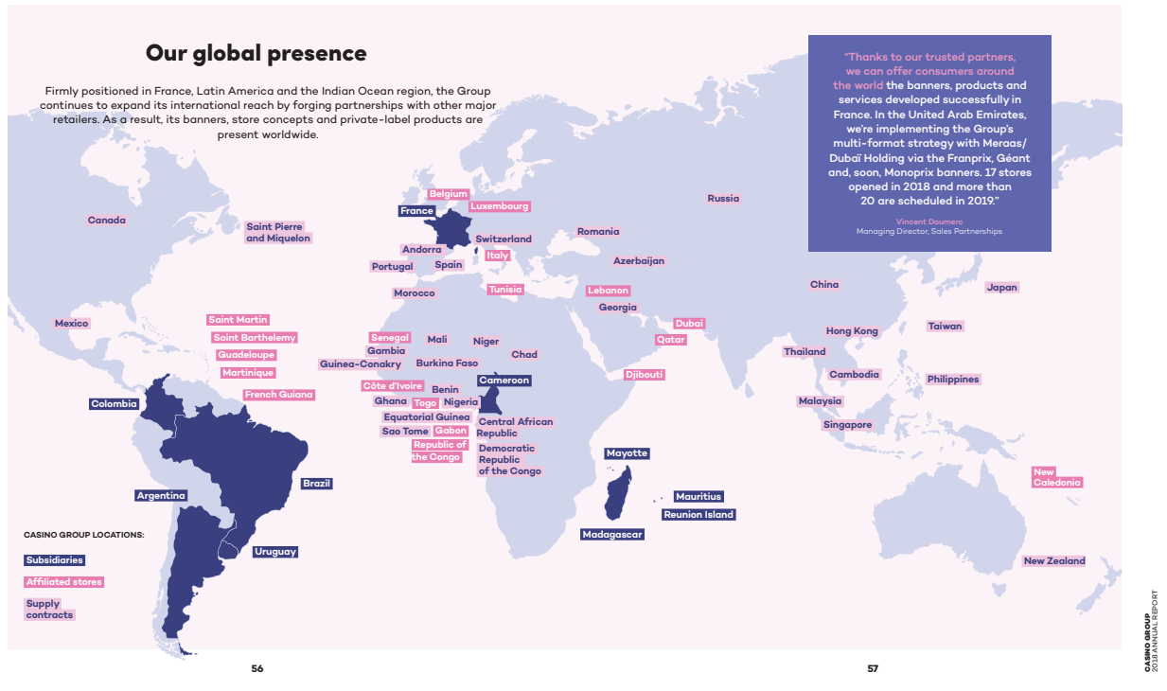

### **In France**

The model developed by Casino is founded on the network of brands with differentiated and complementary positioning.

In Metropolitan France, the Group operates the brands Géant Casino (hypermarkets), Casino Supermarkets, Monoprix, Franprix, Leader Price, Spar, Vival, Le Petit Casino, Casino Restauration.

In [Réunion Island](https://en.wikipedia.org/wiki/R%C3%A9union_Island" \o "Réunion Island), the brands are mainly Score and Jumbo Score.

### **E-business**

Casino Group concentrates its e-business activity within the company, [Cnova](https://en.wikipedia.org/wiki/Cnova" \o "Cnova), created in June 2014   
[Cdiscount](https://en.wikipedia.org/wiki/Cdiscount), branch of Casino Group, became over a few years a major e-business actor over the Internet in France

### **Real estate**

The real estate activity of Casino Group is driven in France by l’Immobilière Casino (which owns the walls of its stores) and its old brand Mercialys

**Formats Owned by the Company**

**Géant Casino-**is a [hypermarket](https://en.wikipedia.org/wiki/Hypermarket) chain based in [Saint-Étienne](https://en.wikipedia.org/wiki/Saint-%C3%89tienne), France, part of the French retailing giant [Groupe Casino](https://en.wikipedia.org/wiki/Groupe_Casino" \o "Groupe Casino).

Géant Casino stores into human scale hypermarkets, really close to customers, focused mainly on the food offer and displaying the lowest prices for mass market commodities.  
 Brand positioning is defined by a threefold commitment: low prices, assured quality and an easier life.

* Format : hypermarket
* Number of stores : 122
* Average surface : 7 400 m²
* Catchment area : suburban



**Casino Supermarkets**

Located in city centres or in rural areas, Casino Supermarkets sell a full, competitively priced range of food products with an average of 13,000 SKUs, including staple goods, a large proportion of Casino-brand items and fresh products.  
Brand positioning is defined by a threefold commitment: low prices, assured quality and an easier life.

* Format : supermarket
* Number of stores : 433
* Average surface : 1 700 m²
* Catchment area : urban



**[Monoprix](https://en.wikipedia.org/wiki/Monoprix" \o "Monoprix)-** It is a major [French](https://en.wikipedia.org/wiki/France) [retail](https://en.wikipedia.org/wiki/Retail) chain with its headquarters in [Clichy, Hauts-de-Seine](https://en.wikipedia.org/wiki/Clichy,_Hauts-de-Seine), [France](https://en.wikipedia.org/wiki/France), near Paris. The company's stores combine food retailing with hardware, clothing, household items and gifts.

* Format : qualitative banner
* Number of stores: 316
* Average surface: 1776 m²
* Catchment area: town or city centres across France and internationally (Tunisia, Mauritius, Libya, Qatar, Luxembourg, Lebanon, Martinique Island)

Monoprix logo.svg

**[Franprix](https://en.wikipedia.org/wiki/Franprix" \o "Franprix)** –It is a [grocery store](https://en.wikipedia.org/wiki/Grocery_store) [chain](https://en.wikipedia.org/wiki/Chain) of the [Groupe Casino](https://en.wikipedia.org/wiki/Groupe_Casino" \o "Groupe Casino), headquartered in [Paris](https://en.wikipedia.org/wiki/Paris).

* Format : convenience banner
* Number of stores: 893
* Average surface: 400 m²
* Catchment area: Paris and Ile-de-France, Lyon region, PACA and Occitanie regions

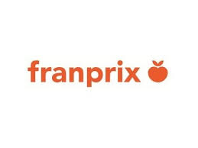

**Leader Price -** It is a [French](https://en.wikipedia.org/wiki/France) [discount store](https://en.wikipedia.org/wiki/Discount_store) chain of the [Groupe Casino](https://en.wikipedia.org/wiki/Groupe_Casino" \o "Groupe Casino), headquartered in [Paris](https://en.wikipedia.org/wiki/Paris), France

* Format : discount supermarket
* Number of stores: 777
* Average surface : 800 m²
* Catchment area : urban and suburban



**Le Petit Casino -** It is in the heart of towns or cities with a wish to recreate the atmosphere of a shopping street. Designed as real living spaces, the importance is given to personal relationships with customers.  
 The brand offers among its aisles food products but also beauty, fashion and home product

* Format : convenience store
* Number of stores : 928
* Average surface : 80 à 500 m²
* Catchment area : city or town centres

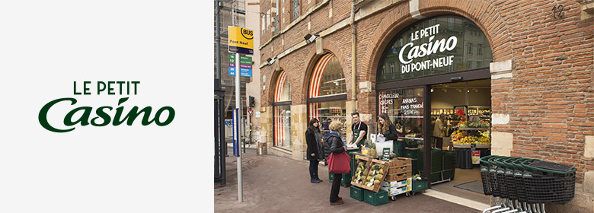

[**Cdiscount**](https://en.wikipedia.org/wiki/Cdiscount) -  is a French e-commerce website with a broad offer: a wide range of products including, among others, cultural goods, high-tech, IT, household appliances, personal appliances and food.

* Format : e-commerce store
* Catchment area : France

**Important numbers :**

* €3.4 billion turnover in 2017
* Over 2 million visitors each day
* 30 million products
* 1 800 employees
* 500 000 m² of warehouses



**[Vival](https://en.wikipedia.org/wiki/Vival" \o "Vival)** -  is a brand of local grocery shops run by [Groupe Casino](https://en.wikipedia.org/wiki/Groupe_Casino" \o "Groupe Casino). Vival can also sometimes be found at petrol stations, such as in the *Aire de service des Haras* on the A28 motorway in Normandy.

The brand has also launched the free library “Vival Livres” offering the opportunity to exchange books freely.

* Format : convenience store
* Number of stores  : 1660 Vival shops
* Average surface : 60 to 150 m²
* Catchment area : countryside or town/city neighbourhood



**Spar** - Spar is the leader in food convenience stores in developing geographical areas and it boasts a recognized brand image thanks to its aisles of traditional products and a strong visual identity.  
It was founded in the [Netherlands](https://en.wikipedia.org/wiki/Netherlands) in 1932, by Adriaan van Well, and now consists of more than 12,770 stores.

* Format : convenience store
* Number of stores  : 860 Spar stores in France
* Average surface : 200 to 1000 m²
* Catchment area : geographical areas in development

https://upload.wikimedia.org/wikipedia/commons/thumb/7/7c/Spar-logo.svg/220px-Spar-logo.svg.png

All of the stores in the Below Region are managed by Casino Group





**Casino Restauration**- Innovative concept, the brand relies on revisited tradition to make the customer feel at home. An accessible restaurant, with a menu offer, a starter and dessert all-you-can-eat buffet selection, especially designed for families.   
The brand offers its customers a healthy and popular cuisine to enjoy every day, at low prices.  
Chefs are creating new recipes through the seasons, while highlighting the raw materials used.

* Format :Traditional restaurants
* Number of outlets  : 100 restaurants
* Average surface : 450 to 650 m²
* Catchment area : suburban shopping areas

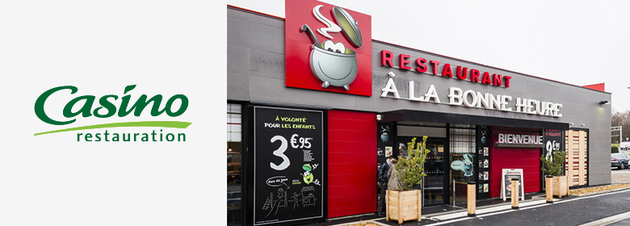



**Sherpa**-Exclusively located in mountain regions, Sherpa is geared towards the winter sports market and as such tends to be the reference at ski resorts, with a clear concept, unique services and an offering designed so that customers can enjoy stress-free holidays.

* Format : convenience stores
* Number of stores: 112
* Average surface : 90 to 400 m²

**3. Financial Modelling**

A financial model is simply a tool that’s built in Excel to forecast a business’ financial performance into the future. The forecast is typically based on the company’s historical performance, assumptions about the future, and requires preparing an income statement, balance sheet, cash flow statement and supporting schedules

**3.1 Company Historical Data**

All of the following data has been collected from Annual Report provided by the company through its official website

Restated Figures have been collected from the statements to make relevant comparisons between the past years.

List of the Statements Prepared

1.Individual Format Sales Statement

2.Income Statement

3.Balance Sheet

4.Cash Flow Statement

5.DCF Valuation

6.Debt Schedule

7.No of Stores

8.Depreciation Schedule

9.Ratios

**3.2. Key Assumptions**

**3.2.1. Revenue Forecasting**

The company’s core revenue is generated from the Sales made in their overall formats.

The sales number for these formats are reported on a Q/Q basis.

Therefore to forecast the number of sales made by the company on an annual basis, which is a total of the all the 4 quarter Sales number

Preparation of a Q/Q Sales for every individual format was undertaken to forecast the sales of every single quarter which is dependent on the Previous Quarter of the same year.

A Sales number for the quarter was forecasted by the laying emphasis on the   
  
Growth over the Previous Quarter = Growth %

Growth % for Forecasting = New Space Growth+ Same Store Growth + Fuel Effects + Calendar Effects

New Space Growth: This is the growth happened due to the addition of the new space added by the company

Same Store Growth: Same-store sales are also known as comparable store sales, identical store sales or like-store sales.

 It is an adjusted growth metric that only includes revenues generated from organically comparable stores or products with similar characteristics and historical sales periods of operation

Analysts frequently use same-store sales to determine the effectiveness of the management of a retail chain in producing revenue growth from existing assets.

For Example:  a same-store sales figure of 7% indicates that total euro revenues at a retail chain's existing locations increased by 7% over the same given time period from the previous year.

Fuel and Calendar Effects: The adjustments to the sales figure by variation in the sales number because of seasonal patterns comes under the Fuel and Calendar Effect.

For Example : People tend to shop more in months when there are more holidays and festivals, which can lead to high sales number for that quarter but the sales may dip over the next quarter , to reduce the impact of such inflated figures are adjusted using this method.

**Assumptions:**

Different Numbers are assumed for every different types of format which is based on the information from Investor Presentation, Future Outlook for the company, Analyst Call Transcripts, and Public News Available on Internet.

From these sources I have taken inspiration for the numbers I’ve used as an input in my model

1.For Formats Like Monoprix, Supermarkets and Leader Price: I’ve assumed a conservative SSG and New Space Assumption because of the company’s plan to reduce the number of these stores and focus on making the existing stores profitable with the help of innovative technologies.

2.For Formats like Franprix ,Hypermarkets and Convenience Stores : I’ve assumed positive SSG and New Space Assumption because of their growing market share in the international markets and stable sales performance over the last past years.

3.For LATAM : Very Conservative SSG and New Space Assumption have been assumed because of the weak macro-economic factors, decline in market share and high pricing competitions between the companies leading to very narrow operating margins.

4.For E-Commerce : Positive SSG and New Space Assumption have been assumed for this segment because of past good performance, willingness of the company to spend more on the business for expansion ,gaining more market share and Omni-channel strategy adopted by the firm.

With the help of these Assumptions, Sales Number till the year 2023 has been forecasted

**3.2.2. COGS and Other Expenses**

**Following Elements have been forecasted using a % of a Related Element based on the past Historical Trends and Future Expected Information provided by the company**

1. **Other Revenue –** As% of Revenue (Involves revenue from non-core business format of the company)
2. **COGS-**As a % of Revenue ( There was no direct statement by the company explicitly stating any useful information which could give me a lead about the COGS ,So I have assumed it to be in sync with the past historical trends)
3. **Selling, Gen and Admin Expenses-** As a % of Revenue (Same Methods as COGS)
4. **Operating Income and Expenses -** As a % of Revenue (For Operating Expenses the company has stated in Investors Presentation of 2019 , to explicitly reduce the cost by 200 million for which adjustments the % number has been adjust accordingly, similar exercise has been done for Operating Income )
5. **Finance Costs -** As a % of Debt in B/S Over the Past year
6. **Other Financial Income and Financial Expense -** As a % of Revenue (the company’s new IFRS 16 adoption will lead to various changes and have an impact on the company’s ability to generate this income because of the inclusion of Lease Payments Received ,therefore an increasing % assumption has been assumed to forecast the increase in Other Operating Income and Increase in Lease Payments which the company will have to pay
7. **Income Tax-** Past Historical Trends has been assumed because of the unpredictability of the tax% the company may need to because of exposure to various international factors.

**3. Debt Assumptions –**The information mentioned by the company for the debt in their future was specifically given in Related to its French Operations

-Where the company plans to reduce the debt in French Segment to less than 1.5 billion euros

-While the company has not mentioned anything about Its Total Debt in any of its Investor Presentation and Reports, but in the investor calls, they have mentioned upon multiple times that they are focusing more and more on deleveraging in future.

So I’ve assumed that company is going to de-leverage in the forecasted period but not by much of a magnitude

So I’ve taken an EBITDA/Total Debt Ratio over the past period and Tried to Reduce that number over a certain % by which the company may deleverage over a period of time.

By a certain basis point as mentioned in the Investor call transcripts

**3.2.3. CFS Assumptions**

**-**Only Items which are going to majorly impact the CFS are

-Cash from Asset disposal – As the company has planned dispose 1.5 billion euros of assets in the year 2019 and and a total of Assets 2.5 billion euros in the Year 2020 and 21 according to the Rocade Plan, these items will majorly impact the Cash flow.

**5.Capex and Depreciation Assumptions**

-As mentioned in the Investor Presentation 2019 and Annual Report 2018 Outook that the company is going to maintain the Capex of around 1 billion euros for the year 2019 and 2020

I’ve assumed the capex figure to be around the same while taking at as a % of Sales

The Capex has been showing a decreasing trend because the firm’s focus more on applying innovation technologies and focusing more on profitability measures.

As the company has mentioned numerous times about expanding or opening new stores,

I’ve assumed a similar trend for FY 20-23, where the capex is decreasing.

**3.2.4. DCF**

* The discounted cash flow (DCF) analysis represents the net present value (NPV) of projected cash flows available to all providers of capital, net of the cash needed to be invested for generating the projected growth.
* The concept of DCF valuation is based on the principle that the value of a business or asset is inherently based on its ability to generate cash flows for the providers of capital.
* To that extent, the DCF relies more on the fundamental expectations of the business than on public market factors or historical precedents, and it is a more theoretical approach relying on numerous assumptions.
* A DCF analysis yields the overall value of a business (i.e. enterprise value), including both debt and equity

1. Project the company’s Free Cash Flows: Typically, a target’s FCF is projected out 5 to 10 years in the future.
2. Determine the company’s Terminal Value: Terminal Value is calculated using one of two methods: the Terminal Multiple Method or the Perpetuity Method. (Note that if the Perpetuity Method is used, the Discount Rate from the following step will be needed.)
3. Determine the company’s Discount Rate: Calculate the company’s Weighted Average Cost of Capital (WACC) to determine the Discount Rate for all future Cash flows.
4. Use Net Present Value: Discount the projected FCF and Terminal Value back to Year o (i.e., back to today) and sum these figures to determine the Enterprise Value of the company.
5. Make Adjustments: If using an Unlevered Free Cash Flow (UFCF) approach, subtracting out net debt and other adjustments from Enterprise Value to derive the Market Value of the company.

**IFRS 16**

**1. Background**

* IFRS 16 supersedes IAS 17 Leases (and related Interpretations) and is effective from 1 January 2019.
* The IASB and the US national standard-setter, the Financial Accounting Standards Board (FASB), have been working jointly to improve the accounting for leases in International Financial Reporting Standards (IFRS) and US Generally Accepted Accounting Principles (US GAAP).
* IFRS 16 completes the IASB’s project to improve financial reporting for leases.

**2. Objective of IFRS 16**

The premise of IFRS 16 is simple: to bring all companies’ leases onto their balance sheets for 2019 accounting periods onwards.

*The objective of IFRS 16 is to report information that*

*(a) Faithfully represents lease transactions and*

*(b) Provides a basis for users of financial statements to assess the amount, timing and uncertainty of cash flows arising from leases.*

To meet that objective, a lessee should recognize assets and liabilities arising from a lease.

* IFRS 16 introduces a single lessee accounting model and requires a lessee to recognize assets and liabilities for all leases with a term of more than 12 months, unless the underlying asset is of low value.
* A lessee is required to recognize a right-of-use asset representing its right to use the underlying leased asset and a lease liability representing its obligation to make lease payments.

**3. Scope of IFRS 16**

* The scope of IFRS 16 is generally similar to IAS 17 and includes all contracts that convey the right to use an asset for a period of time in exchange for consideration, except for licenses of intellectual property granted by a lessor, rights held by a lessee under licensing agreements (such as motion picture films, video recordings, plays, manuscripts, patents and copyrights), leases of biological assets, service concession agreements and leases to explore for or use minerals, oil, natural gas and similar non-regenerative resources.
* There is an optional scope exemption for lessees of intangible assets other than the licenses mentioned above
* IFRS 16 includes detailed guidance to help companies assess whether a contract contains a lease or a service, or both.
* Under current guidance and practice, there is not a lot of emphasis on the distinction between a service or an operating lease, as this often does not change the accounting treatment.
* The analysis starts by determining if a contract meets the definition of a lease.
* This means that the customer has the right to control the use of an identifiable asset for a period of time in exchange for consideration.

**4. Key Changes because of IFRS 16**

* The key elements of the new standard and the effect on financial statements are as follows:
* A ‘**right-of-use**’ model replaces the ‘**risks and rewards’** model. Lessees are required to recognize an asset and liability at the inception of a lease.
* All lease liabilities are to be measured with reference to **an estimate of the lease term**, which includes optional lease periods when an entity is reasonably certain to exercise an option to extend (or not to terminate) a lease.
* **Contingent rentals or variable lease payments** will need to be included in the measurement of lease assets and liabilities when these depend on an index or a rate or where in substance they are fixed payments.
* A lessee should reassess variable lease payments that depend on an index or a rate when the lessee re-measures the lease liability for other reasons and **when there is a change in the cash flows resulting from a change in the reference index or rate**
* Lessees **should reassess the lease term** only upon the occurrence of a significant event or a significant change in circumstances that are within the control of the lessee.

**5. How the Various Items in Financial Statements will be Affected?**

* The new standard will affect virtually all commonly used financial ratios and performance metrics such as **gearing, current ratio, asset turnover, interest cover, EBITDA, EBIT, operating profit, net income, EPS, ROCE, ROE and operating cash flows.**
* These changes may affect loan covenants, credit ratings and borrowing costs, and could result in other behavioral changes.
* These impacts may compel many organizations **to reassess certain ‘lease versus buy’ decisions.**
* Balance sheets will **grow**, gearing ratios will increase, and capital ratios will decrease.
* There will also be a change to both **the expense character** (rent expenses replaced with depreciation and interest expense) and **recognition pattern** (acceleration of lease expense relative to the recognition pattern for operating leases today).
* Entities leasing ‘**big-ticket’ assets** – including real estate, manufacturing equipment, aircraft, trains, ships, and technology – are expected to be greatly affected.
* Low value assets meeting this **exemption** do not have to be recognised on the balance sheet
* The cost to implement and continue to comply with the new leases standard could **be significant for most lessees**. Particularly if they do not already have an in-house lease information system.

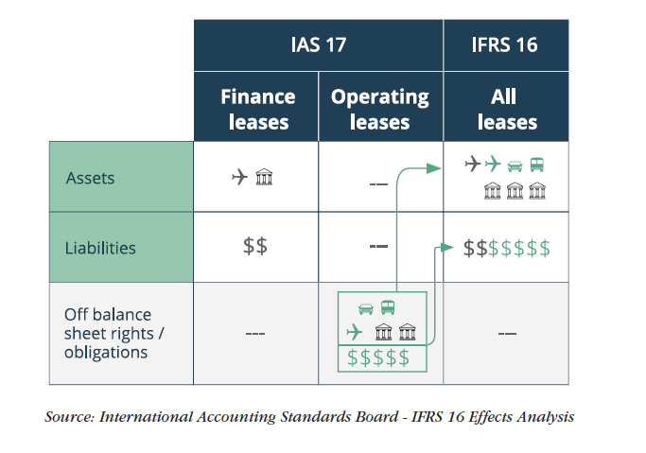**Easy Diagram-Based Explanation**

* **Impact on Balance Sheet**
* Adoption of IFSR 16 results in a material increase in assets and liabilities, but with a net increase in liabilities, resulting in a move from an overall net asset position to a net liability position.
* Lease liabilities will be classified as financial liabilities, and therefore will impact reported financial indebtedness, balance sheet ratios and covenants.

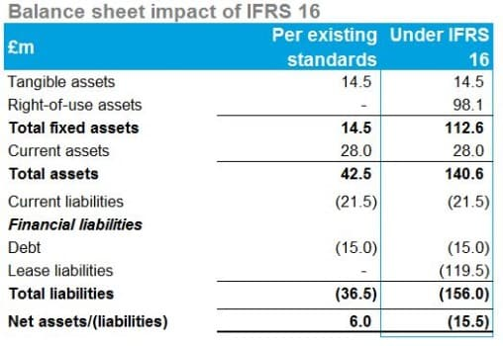

* **Impact on Income Statement**
* Overall there is a limited impact on reported profit before tax, but EBITDA and EBIT are increased materially, with property lease costs now being shown as depreciation and interest expenses.
* This will impact on banking covenants and leverage ratios derived from standard income statement measures such as EBITDA and EBIT..

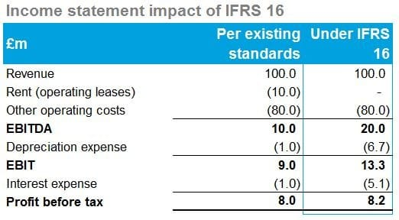

**6. Impact of IFRS 16 On Retail Industry**

Although virtually every industry uses leasing as a means to obtain access to assets, the type and volume of assets that they lease, and the terms and structures of these lease agreements differ significantly

**Retail Sector**

Retaily industry majorly uses leases for their stores. They are likely to experience major impacts when implementing the new leases standard:

* **Renewal options** – leasing real estate is retailers’ core business and determining and reassessing when a retailer has an economic incentive to renew a retail lease location may require substantial judgement.
* **Variable payments linked to index or rate** – retailers need to put systems in place to estimate and remeasure variable payments linked to an index at the spot rate for each reporting period (e.g. CPI).
* Historically, such leases have been considered as operating leases, and have not therefore had any impact on the balance sheet. The amount recorded in the income statement was typically on a straight line basis and included in operating expenses.
* The new lease standard will not only have an impact on the balance sheet, but also on the operating costs, with a split of the expense between operating and finance costs.
* Retailers, who often lease many properties to use as retail spaces would, in particular, be impacted by this change because currently these leases of properties are not included as liabilities in the financial statements of retailers. Going forward, the retailers would now recognise these leases as a right-of-use asset and a corresponding lease liability in the statement of financial position. It should be noted that the right-of-use asset is a non-current asset, whereas the liability would be split into a current and a non-current portion.
* As a result of IFRS 16 implementation, net debt across the S&P Euro 350 largest listed European corporates is expected to increase by 16% to €306bn. This figure will be heavily skewed towards companies in sectors such as retail, transport and aviation. However, it should be noted there will be no cash impact on companies once IFRS 16 comes into force and the rating agencies have already factored in the risk.
* Retailers such as Sainsbury’s, Marks & Spencer, and Tesco typically lease a large footprint of real estate for their stores and distribution centres as well as IT assets such as servers, storage, and data centre equipment to support their e-commerce operations

**7. IFRS 16 Impact on Individual Retail Companies in Europe**

**Balance Sheet Observations**

1 .As we can observe the Right-Of-Use Assets sections which has been added to each of the following companies balance sheet has increased the Assets by that amount which has also led to changes in

-An Increase in Total Assets for all of the companies   
-An Overall effect of change on Total Equity and Liabilities

2 .A Change in the non-current financial liabilities section of the companies this impact is majorly dependent upon the lease liabilities which a company has and varies company to company according to it.

|  |  |  |  |  |
| --- | --- | --- | --- | --- |
| Key Balance Sheet Elements Comparison  (€ million) or % Change over previous year | Morrisons (FY/19) | Tesco Plc (FY/19) | Alhord Delhaize(Q1/19) | Casino Groupe (H1/19) |
| Right-of-use assets | 929 | 7,527 | 7,027 | 4,982 |
| Current assets | 8.8% | -1% | 1% | 1% |
| Total assets | 7.6% | 13% | 19% | 14% |
| Total equity | -6.6% | -12% | -4% | -3% |
| Non-current financial liabilities | 1.6% | -2% | 4% | -0.41% |
| Total equity and liabilities | -6.6% | -12% | 19% | 14% |

**Income Statement Observations**

|  |  |  |  |  |
| --- | --- | --- | --- | --- |
| Income Statement Element Comparison (€ million) or % Change over previous year | Morrisons (FY/19) | Tesco Plc (FY/19) | Alhord Delhaize(Q1/19) | Casino Groupe (H1/19) |
| Revenue | 0.00% | 0% | 0.0% | 0% |
| COGS | -0.26% | -1% | 0.0% | -0.24% |
| Operating Proft | 9.64% | 23% | 8.5% | 25.7% |
| Finance Cost | 57.73% | 103% | 87.5% | 82.5% |
| Finance Income | 4.55% | 14% | 200.0% | -1.9% |
| Tax | -7.89% | -2% | -1.9% | -34.8% |

1. No Impact on Revenue
2. As observed by the table ,COGS have been reduced by a -1% to 0.24% range ,which can be used to draw a conclusion that would also follow to a higher G/P number which may lead to better Margins for majority of the players.
3. Operating Profit has increased from 8.5% to 25.7% ,as an impact of Lease as an expenses removed from the Operating Expenses which leads to high Operating Margins
4. Finance Cost and Income has seen an increase because of the firms accounting lease payments received or expensed under this head which were earlier kept off balance sheet

**Cash Flow Observations**

|  |  |  |  |  |
| --- | --- | --- | --- | --- |
| Key Metrics for Cash Flow (€ million) or % Change over previous year | Morrisons (FY/19) | Tesco Plc (FY/19) | Alhord Delhaize(Q1/19) | Casino Groupe (H1/19) |
| CFO | 16% | 18.2% | -1.0% | -14% |
| Lease Payment | 122% | 193.3% | -44.4% | 35% |
| Repayment of New or Extra Lease Obligations under IFRS 16 | +69 | +588 | +320 | +343 |

1. An Decrease/Increase in the CF from Operations can be attributed to the payment for leases which were earlier made under the Core Operating Expenses

2. An Increase in the Lease Payments amount is because of the IFRS 16 leases expense recognition clauses

3. Extra Lease Obligation has been added in the CFS of every company as an impact of IFRS 16.

**Reference Material**

**References**

1. <https://www.crisil.com/en/home/about-us.html>
2. <https://www.thebalancesmb.com/biggest-european-retail-chains-list-2892256\>
3. <https://www2.deloitte.com/content/dam/Deloitte/global/Documents/Consumer-Business/cons-global-powers-retailing-2019.pdf>
4. <https://en.wikipedia.org/wiki/Groupe_Casino>
5. <https://www.wallstreetmojo.com/dcf-discounted-cash-flow/>
6. <https://www.groupe-casino.fr/en/sales-figures-archive/>
7. <https://www.groupe-casino.fr/en/investors/financials-informations/>
8. <https://www.ifrs.org/issued-standards/list-of-standards/ifrs-16-leases/>
9. <https://www.pwc.com/gx/en/services/audit-assurance/assets/ifrs-16-new-leases.pdf>
10. <https://www.ifrs.org/-/media/project/leases/ifrs/published-documents/ifrs16-effects-analysis.pdf>
11. <https://www.tescoplc.com/>
12. <https://www.about.sainsburys.co.uk/>
13. <https://www.aholddelhaize.com/en/home/>